The SOUTHERN THOMSON PROJECT – LOOKING INTO THE BASEMENT OF A NEW FRONTIER TERRANE

Rosemary Hegarty
Geological Survey of New South Wales, NSW Department of Industry, Maitland NSW 2320
Keywords: Thomson Orogen, electromagnetics, magnetotellurics, basement geology, geochronology, mineral systems

Abstract
The Southern Thomson Project aims to better understand the geological character and mineral potential of the southern Thomson Orogen region (focusing on the border region between New South Wales and Queensland, Figure 1a) by acquiring and interpreting multi-disciplinary geophysical, geochemical and geological data. It is a collaborative venture between the Geological Survey of New South Wales (GSNSW), the Geological Survey of Queensland (GSQ) and Geoscience Australia (GA), and is compatible with the Australian Academy of Science’s UNCOVER initiative. To aid the discovery of mineral deposits and new mineral systems in this region, the Southern Thomson Project aims to provide the mineral exploration industry with pre-competitive data, information and knowledge that will reduce risk and encourage exploration.
The Thomson Orogen lies concealed under younger sedimentary basins (some up to several kilometres thick) and regolith cover over a large region of New South Wales, South Australia, Northern Territory and Queensland. It is one of the least well understood elements of Australia’s geology and, as a result, the mineral potential of the region is also poorly defined. Key sources of information about the basement geology have been:
- widely spaced petroleum boreholes and seismic lines,
- basic lithological information from numerous water bores,
- some recent mineral exploration drillholes,
- geological mapping from adjoining areas of outcrop,
- interpretation of regional aeromagnetic and gravity surveys, and
- deep seismic lines by government agencies.

The southern extent of the Thomson Orogen in New South Wales was originally defined from regional geophysical data as a demarcation between the northerly structural trends of the Lachlan
Detailed investigations of the Southern Thomson project area under the first phase National Collaborative Framework (NCF) agreement are almost complete. Geophysical acquisition was done along major regional traverses for magnetotelluric (MT), audio magnetotelluric (AMT), gravity and airborne electromagnetic (AEM) surveys, with a regional AEM survey flown across the Eulo Ridge basement high. The first phase of the project also included the synthesis of existing information and analysis of new data for structural geology and deformational history, geochronology, and mineral systems, and compilations of solid geology basement mapping of the entire study area. Full reporting of the first phase results will occur by the end of 2015, and some of the preliminary outcomes on basement geology are summarised below. A new NCF agreement has commenced in for phase two investigations from 2015 to 2017, including ground geophysical surveys and stratigraphic drilling of selected key sites.

AEM for conductivity and basement depth
Quantitative information on depth to basement (DTB) is a critical challenge facing mineral exploration as Eromanga Basin sedimentary rock sequences vary in thickness, but are typically from 200 m to 400 m over a large part of the study area. A regional helicopter AEM survey using the Geotech Airborne Ltd VTEMplus® system was flown on and around the outcropping parts of the Eulo Ridge and south into northern NSW. The survey area covered approximately 16 261 km² (4268 line km) with east–west flight lines at a spacing of 5 km (Figure 2a). Data were processed initially by the contractor, and then two types of layered earth inversion developed by Geoscience Australia (GALEISBS “layer by layer” and GARJMCMC “Monte Carlo”) were applied (Figure 2b). Both of these data packages can be downloaded from the GA website.

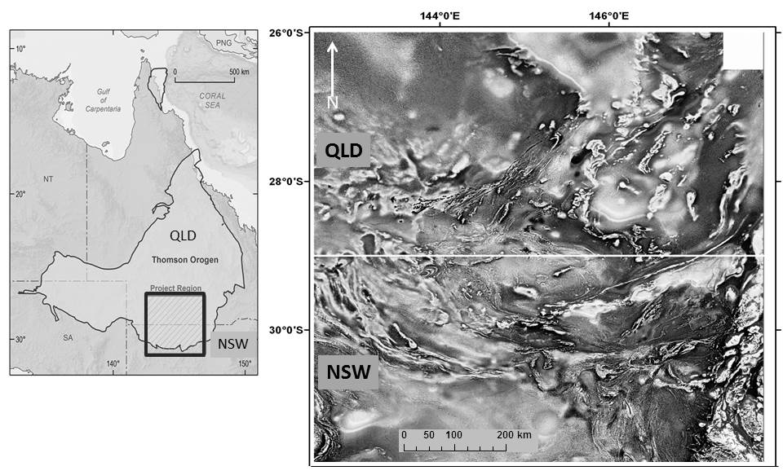

Figure 1: (a) Location of the Thomson Orogen showing the Southern Thomson Project area straddling the state border, and (b) basement-sourced magnetic trends on greyscale 1VD TMI RTP image showing complex structural patterns within the study region.

A comprehensive report on the AEM survey results (edited by I. Roach, in prep.) includes:
- the AEM signal depth of investigation (DOI),
- interpretation of the conductivity section to define stratigraphy and hydrostratigraphy of cover rocks and local neotectonic effects,
- construction of a basement elevation model,
- interpretation of resistive and conductive features related to basement, and
- assessment of the patterns and depth of weathering over basement rocks.

The AEM survey successfully mapped the basement–cover interface over a large part of the Eulo Ridge using the 5 km line-spaced data. Identification of areas having previously unrecognised basement under thin cover has substantiated the application of this AEM technique (and survey system). Defining cover characteristics, basement depths and conductivity details, AEM data can be used to identify opportunities for mineral exploration and drilling.

Crustal architecture geophysical transects
Regional traverses to transect the dominant, but complex, structural fabrics evident in regional potential field data have been completed. Combined assessment of the following will investigate the upper and lower crust:
- gravity measurements at 333 m spacing
- broadband MT which provides a deep conductivity picture down to lithospheric depth
- some local high-resolution Audio MT to understand conductivity at depths between shallow AEM penetration and MT depths.

Modelling of gravity and MT data is still in progress. When complete it the interpretations will help understand major structures that may control basement mineralisation within the southern Thomson Orogen, including the relationship between the Thomson Orogen and the Lachlan Orogen to its south. The western traverse overlaps with the 2005 deep seismic reflection survey acquired by GSNSW and GA across the Olepoloko Fault in the Tilpa area.

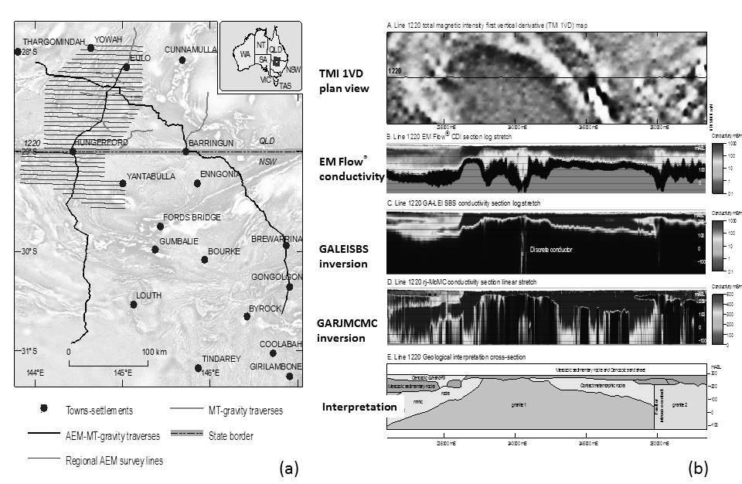 Figure 2: (a) Location of geophysical surveys acquired during the first phase of the Southern Thomson Project, and (b) greyscale 1VD TMI RTP image, conductivity sections and interpreted geology for AEM flight line 1220 over the Hungerford Granite (from Roach, in prep).

Solid geology, structure and geochronology
A composite NSW–Qld solid geology interpretation map has been compiled based on aeromagnetic and gravity data (Figure 3). It incorporates existing stratigraphic and structural frameworks from regional mapping in the region by workers including Greenfield et al. (2010) for the Koonenberry Belt and Gilmore et al. (in prep.) for the Mount Oxley area. This map provides a framework for analytical planning and a useful context for interpreting results. The cross-border project area extent reveals a much larger picture, where various structural sets – both ductile and brittle – combine to form an envelope of northeasterly trending aeromagnetic patterns approximately 300 km wide. Basement rocks of the Eulo Ridge occur along the northwest side, and the Culgoa and Louth–Eumarra shear zones occur along the southeast side. Limited age dates from the central area (from granite outcrops only) suggest that overall the main structural element is probably a dome. Analytical work is progressing to obtain 16 magmatic ages and detrital provenance (i.e. maximum depositional) ages for host metasedimentary rock units using U–Pb SHRIMP dating throughout the study area. Isotopic dating is also underway on muscovite (Ar–Ar) and fine clays (K–Ar) for ages of metamorphism and deformational fabrics in selected areas (37 samples in total). These results will combine to improve overall understanding of the stratigraphy and tectono-thermal history, and correlations can be made within the provinces and geodynamic frameworks of the Tasmanides.
Detrital zircon provenance populations of new samples from industry drillcore and Geological Survey stratigraphic bores and core tails add to existing geochronology results. With the new data, comparison of maximum detrital ages is now showing some significant correlations for particular age spectra. However, some of the major interpreted units recognised from distinctive aeromagnetic character, such as the Werewilka formation in Qld, still have no samples available for analysis until they are drilled.
Geodynamic interpretations are evolving through an integration and re-assessment of existing seismic data with scarce basement information available. Further east between Brewarrina and Enngonia, the Paka Tank Trough has >1.5 km thickness of Middle to Late Devonian sedimentary rocks. Potential field studies at GA (by Geological Survey of India) modelled across the trough and incorporated strongly magnetised felsic volcanic rock as a basal unit beneath the red bed sequence. Strongly magnetic diorite and porphyry samples from drill holes northwest of Bourke (explored by Meridian Minerals Limited) produced two magmatic crystallisation ages of around 400 Ma by U–Pb SHRIMP dating at Geoscience Australia. A sample of a volcanic-proximal red bed sequence in the Tuncoona area north of Bourke exhibits a strong detrital zircon cluster at around 400 Ma also (Fraser pers. comm. 2014). These results are showing that broader age patterns and linking relationships are starting to emerge as more geochronological samples are processed.
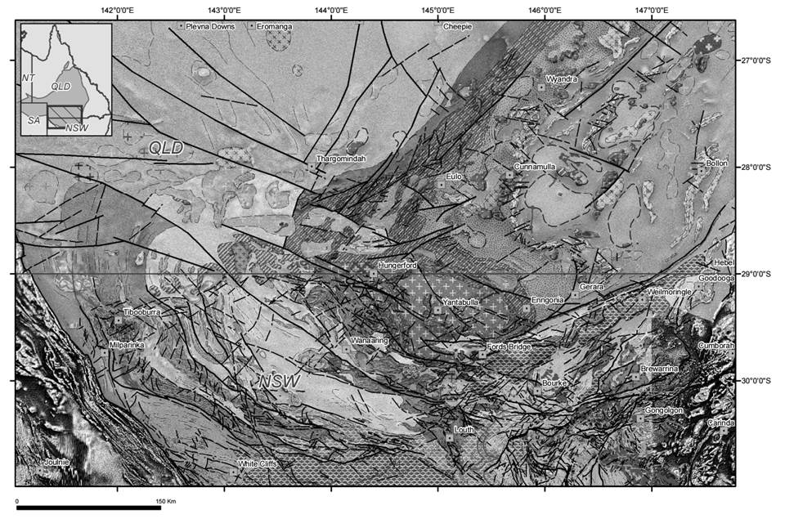Figure 3: Solid geology interpretation map overlain as transparency on 1VD TMI RTP image (original is in colour, with legend)

Mineral systems and geochemistry
New isotopic studies aim to reassess prospectivity for mineralisation including base and precious metals, nickel and uranium. Links with nearby mineral systems are explored to provide context, including mineralisation around Tibooburra (orogenic Au), Cobar (syn-deformational Au and base metals), Doradilla (hydrothermal Cu, skarn Sn and lateritic Ni) and Girilambone (VHS Cu and Au) in NSW, and also the vein-hosted Au mineralisation in old mine workings at Granite Springs in Qld.
One area of mineral systems focus has been two undercover prospects – Cuttaburra and F1 – located north of the Olepoloko Fault near White Cliffs, in the southwest of the project area. Exploration drilling reported by Thomson Resources Limited (Rothery 2013, 2014) found indications of Au, Mo and W mineralisation associated with hydrothermally veined and altered metasedimentary rocks and disseminated within I-type granite. Detailed isotopic studies done on company core as part of the Southern Thomson Project have determined new paragenetic and dating results (summarised here from Armistead et al., in prep.):
- An early magmatic-hydrothermal stage (H1) is characterised by disseminated molybdenite, pyrite, pyrrhotite and chalcopyrite hosted within granites. New SHRIMP U–Pb zircon ages (Armistead & Fraser 2015) and previously dated granite in the region indicate that the host granites crystallised between ~429 Ma and 425 Ma. The ages indicated by Re–Os analysis of molybdenite from this assemblage also lie within uncertainty of those magmatic crystallisation ages. New δ³⁴S data from H1 sulfides are consistent with a magmatic-hydrothermal source of sulfur.
- A second hydrothermal event (H2) is characterised by molybdenite, chalcopyrite, pyrite and pyrrhotite which are hosted by chlorite–muscovite–calcite veins that cross-cut the granites. A third hydrothermal mineralisation event (H3) is characterised by chalcopyrite, arsenopyrite, galena, pyrite, pyrrhotite, sphalerite, molybdenite and electrum hosted by quartz–calcite veins that cross-cut the granite and metasedimentary package. Lead isotope values of the galena (Huston, unpublished data; Rothery 2013) from this assemblage are similar to those from Cobar Cu–Au deposits and produce locally constrained model ages of ~400–360 Ma. New δ³⁴S data for samples from the H2 and H3 assemblages are higher than those from the H1 assemblage, and further support a hydrothermal rather than magmatic source of sulfur.

Another area of minerals focus investigation has been an ultramafic intrusion at the Pirelli prospect, north of Bourke, for PGE potential. The ultramafic rocks are the source of linear magnetic anomalies on an eastnortheast trend located within the Culgoa Shear Zone (or lineament). Studies included petrography and SEM, with major and trace element geochemistry for 12 samples of drillcore, and results have been compared with other ultramafic intrusions such as the Fifield Complex.
Acquisition of surface geochemical data in the Hungerford area continues to build baselines for surface geochemical background values. Consideration of MMI results and geochemical dispersion vectors is in progress to identify and characterise distal footprints within potentially mineralised terranes under cover.

ARC Linkage Project
Professor Bill Collins and the University of Newcastle are Chief Investigators of a new Collaboration Research Agreement which will run for three years and complement the outcomes of the NCF Southern Thomson Project. The project is titled “The Missing link in the Tasmanides: evaluating tectonic evolution and resource exploration potential of the southern Thomson Fold Belt”. Other Investigator organisations are the University of Queensland and the Queensland University of Technology, with GSQ and GSNSW as Partner Investigators. The Honours, Masters and PhD projects are tackling key topics which provide depth and detail to build tectono-stratigraphic understanding:
- “Uncovering the Southern Thomson Orogen, NSW: Geodynamic Significance of Warraweena Volcanics and Related Rocks” (results in prep. for publication) is an Honours thesis completed by Sarah Whalan, 2014, at University of Newcastle. Geochemistry, LA_ICP_MS U/Pb zircon geochronology and Sm–Nd results considered for the volcanic rocks and surrounding units.
- “Age and provenance of the Cobar Supergroup” (results in prep. for publication) is an Honours thesis completed by Matthew Parrish, 2014, at University of Newcastle. This LA_ICP_MS study of detrital provenance builds the baseline for comparison within the Thomson Orogen.
- “Structure and kinematics of the Louth–Eumarra Shear Zone (north-central New South Wales, Australia) and implications for the geodynamics of the Thomson–Lachlan boundary” (thesis submitted June 2015 by Sam Dunstan, University of Queensland)
- Regional study integrating structural and seismic by Rashed Abdullah, University of Queensland started in 2014
- New project to understand the age and nature of the Louth Volcanics, commenced by Ryan Dwyer, University of Newcastle in July 2015.

Phase two NCF plans commencing 2015
The new data sets and the synthesis generated in the first phase of the Southern Thomson Project will aid in selecting areas for further analysis in the second phase. The three year NCF collaborative agreement underway is testing interpretations of the undercover geology by studying several key areas where geology and structure may be resolved. Appropriate methods of ground geophysical surveying including seismic refraction (using accelerated weight drop), resistivity and IP, passive seismic, gravity and magnetic data will gather quantitative details on cover and basement surfaces. In suitable sites this will be followed by drilling of stratigraphic targets to gain drillcore for lithological and analytical work.
When released, the data will be available to research organisations including the CSIRO, universities and cooperative research centres including the Deep Exploration Technologies CRC and the Data to Decisions CRC. The data collected will also be of use to State and Federal government agencies and private companies engaged in natural resource and water management as well as being available to the project parties for additional research and analysis.
The Southern Thomson Project will continue to provide the mineral exploration industry with new pre-competitive geological, geophysical and geochemical data in this under-explored area. It is also developing techniques for reducing exploration risk in challenging greenfields regions, providing generic work flows and knowledge that will be applicable elsewhere in New South Wales, Queensland and other parts of Australia.

References
Armistead, S. E. and Fraser, G. L., in prep. New SHRIMP U-Pb zircon ages from the Cuttaburra and F1 prospects, southern Thomson Orogen, New South Wales. Geoscience Australia, Canberra.
Armistead, S. E., Skirrow, R. G., Champion, D. C, Huston, D. L, Fraser, G. L and Norman, M. D., in prep. Mineral systems evolution of the Cuttaburra and F1 prospects, southern Thomson Orogen. Geoscience Australia, Canberra
Burton, G.R., 2010. New structural model to explain geophysical features in the northwest of New South Wales: implications for the tectonic framework of the Tasmanides. Australian Journal of Earth Sciences 57 (1), pp 23 – 49.
Cayley, R., 2014. The Lachlan Orocline of Eastern Australia. Giant folds, the geodynamic processes that can form them, and how these new understandings have potential to revolutionise the resource prospectivity game in Eastern Australia. Geological Survey of Victoria. Abstract from presentation at the New Perspectives Workshop held by Australian Institute of Geoscientists, Victoria.
Gilmore, P.J., Campbell, L,M. & Trigg, S.J., in preparation. Mount Oxley 1:100 000 geological sheet 8137. Explanatory notes. Geological Survey of New South Wales, Maitland, NSW.
Glen, R.A., Korsch, R.J., Hegarty, R., Saeed, A., Poudjom Djomani, Y., Costello, R.D. & Belousova, E., 2013. Geodynamic significance of the boundary between the Thomson Orogen and the Lachlan Orogen, northwestern New South Wales and implications for Tasmanide tectonics. Australian Journal of Earth Sciences 60 (3), pp 371 – 412.
Greenfield, J.E., Gilmore, P.J. & Mills, K.J. (compilers) 2010. Explanatory notes for the Koonenberry Belt geological map. Geological Survey of New South Wales, Bulletin 35.
Hegarty, R., 2010. Preliminary geophysical–geological interpretation map of the Thomson Orogen, NSW. Release of provisional and preliminary information [DVD]. Geological Survey of New South Wales. NSW Department of Industry, Maitland, NSW.
Murray, C.G., & Kirkegaard, A.G., 1978. The Thomson Orogen of the Tasman orogenic zone. Tectonophysics vol 48, pp 299 – 325.
Purdy, D.J., Carr P.A. &​ Browne D.D., 2013. A review of the geology, mineralisation, and geothermal energy potential of the Thomson Orogen in Queensland. Geological Survey of Queensland Record 2013/01. Brisbane Qld.
Roach, I.C. (editor), in prep. The Southern Thomson Orogen VTEMplus® AEM Survey: using airborne electromagnetics as an UNCOVER application. Geoscience Australia Record.
Rothery, E., 2013. A new intrusion-related gold field in the Thomson Fold Belt. Abstract from presentation at the Mineral Exploration in the Tasmanides conference, Australian Institute of Geoscientists Bulletin 55, pp 143–152.
Rothery, E., 2014. NSW New Frontiers – New concepts. Presentation at 8th Annual Mining NSW Conference, Orange.
Spampinato, G.P.T., Betts, P.G., Ailleres, L. & Armit, R.J., 2015. Early tectonic evolution of the Thomson Orogen in Queensland inferred from constrained magnetic and gravity data. Tectonophysics vol 651-652, Elsevier, Amsterdam, Netherlands, pp. 99–120.

Acknowledgements
The Southern Thomson Project is a true collaborative effort. The presenter wishes to acknowledge that this update (given mid-2015) incorporates results achieved by many individuals from Geoscience Australia, with contributions also by geoscientists from the Geological Survey of Queensland and the Geological Survey of New South Wales. With so many project activities it is not possible to name all people involved, but I acknowledge and appreciate the assistance received from Ian Roach, Sheree Armistead, Michael Doublier and Geoff Fraser to prepare this talk. I wish to also extend thanks for the consistent support provided by managers within all the groups, and the cooperation between project managers Dave Purdy (GSQ) and Andrew McPherson (GA, during 2013/2014).

